Section 12.1: Inverse Variation

SOLs: None

Objectives: Students will be able to:
Graph inverse variations
Solve problems involving inverse variations

Vocabulary:
Inverse Variation –
Product Rule –

Key Concept:

Examples:
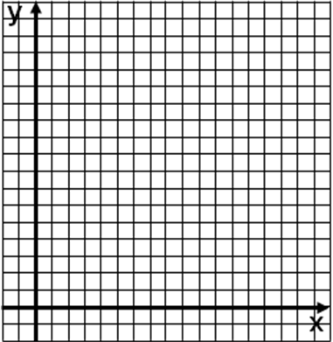
- Manufacturing: The owner of Superfast Computer Company has calculated that the time t in hours that it takes to build a particular model of computer varies inversely with the number of people p working on the computer. The equation pt = 12 can be used to represent the people building a computer. Complete the table and draw a graph of the relation.
p | 2 | 4 | 6 | 8 | 10 | 12
t
- Graph an inverse variation in which y varies inversely as x
and y = 1 when x = 4
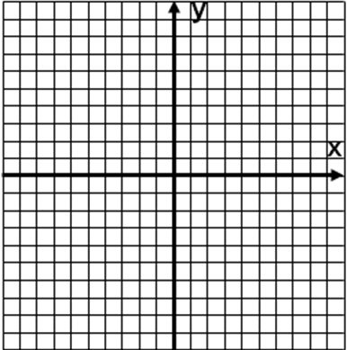
- If y varies inversely as x and y = 5 when x = 12 find x when y = 15.

- If y varies inversely as x and y = 8 when x = 6 find y when x = 4.
- Physical Science: When two objects are balanced on a lever, their distances from the fulcrum are inversely proportional to their weights. How far should a 2-kilogram weight be from the fulcrum if a 6-kilogram weight is 3.2 meters from the fulcrum?

Concept Summary:
The product rule for inverse variations states that if (x₁, y₁) and (x₂, y₂) are solutions of an inverse variation, then x₁y₁ = k and x₂y₂ = k
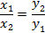
You can use to solve problems involving inverse variations

Homework: pg
Section 12.2: Rational Expressions

SOLs: The student will
A.15 given a rule, find the values of a function for elements in its domain and locate the zeros of the function both algebraically and with a graphing calculator. The value of f(x) will be related to the ordinate on the graph.

Objectives: Students will be able to:
- Identify values excluded from the domain of a rational function
- Simplify rational expressions

Vocabulary:
rational expression –
excluded values –

Key Concept:

Examples:

- State the excluded value of .
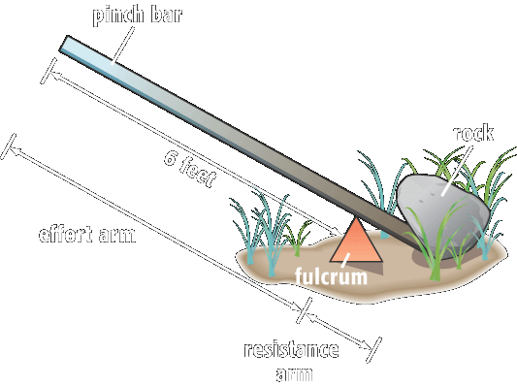
- State the excluded value of 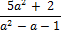
- Landscaping: Refer to Example 3 on page 649. Suppose Kenyi finds a rock that he cannot move with a 6-foot bar, so he gets an 8-foot bar. But this time, he places the fulcrum so that the effort arm is 6 feet long, and the resistance arm in 2 feet long. Explain whether he has more or less mechanical advantage with his new setup.
- Simplify 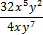
- Simplify 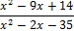
- Simplify and state the excluded values of x

Concept Summary:
Excluded values are values of a variable that result in a denominator of zero

Homework: pg
Section 12.3: Multiplying Rational Expressions

SOLs: The student will
A.3 justify steps used in simplifying expressions and solving equations and inequalities. Justifications will include the use of concrete objects; pictorial representations; and the properties of real numbers, equality, and inequality.

Objectives: Students will be able to:
- Multiply rational expressions
- Use dimensional analysis with multiplication

Vocabulary:
None new

Key Concept:

Examples:

- Simplify the following
A. 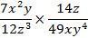
B. 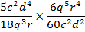
- Simplify the following
A. 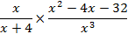
B. 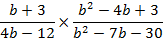
- Space: The velocity that a spacecraft must have in order to escape Earth’s gravitational pull is called the escape velocity. The escape velocity for a spacecraft leaving Earth is about 40,320 kilometers per hour. What is this speed in meters per second?

Concept Summary:
- Finding common factors to simplify numbers
- Multiplying rational expressions is similar to multiplying rational numbers

Homework: pg
Section 12.4: Dividing Rational Expressions

SOLs: The student will
A.3 justify steps used in simplifying expressions and solving equations and inequalities. Justifications will include the use of concrete objects; pictorial representations; and the properties of real numbers, equality, and inequality.

Objectives: Students will be able to:
Divide rational expressions
Use dimensional analysis with division

Vocabulary:
None new

Key Concept:

Examples:

- Find 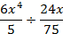
- Find 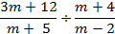
- Find 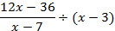
- Find 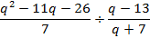
- Aviation: In 1986, an experimental aircraft named Voyager was piloted by Jenna Yeager and Dick Rutan around the world non-stop, without refueling. The trip took exactly 9 days and covered a distance of 25,012 miles. What was the speed of the aircraft in miles per hour? Round to the nearest mile per hour.

Concept Summary:
Divide rational expressions by multiplying by the reciprocal of the divisor

Homework: pg
Section 12.5: Dividing Polynomials

SOLs: The student will
A.3 justify steps used in simplifying expressions and solving equations and inequalities. Justifications will include the use of concrete objects; pictorial representations; and the properties of real numbers, equality, and inequality.

Objectives: Students will be able to:
Divide a polynomial by a monomial
Divide a polynomial by a binomial

Vocabulary:
None new

Key Concept:

Examples:

- Find (4x² – 18x) ÷ 2x.
- Find (2y² – 3y – 9) ÷ 3y.
- Find (2r² + 5r – 3) ÷ (r + 3).
- Find (x² + 7x – 15) ÷ (x – 2). (Use long division)
- Find (x³ – 34x + 45) ÷ (x – 5). (Use long division)

Concept Summary:
To divide a polynomial by a monomial, divide each term of the polynomial by the monomial
To divide a polynomial by a binomial, use long division

Homework: pg
Section 12.6: Rational Expressions with Like Denominators

SOLs: None

Objectives: Students will be able to:
Add rational expression with like denominators
Subtract rational expression with like denominators

Vocabulary:
None new

Key Concept:

Examples:

- Simplify
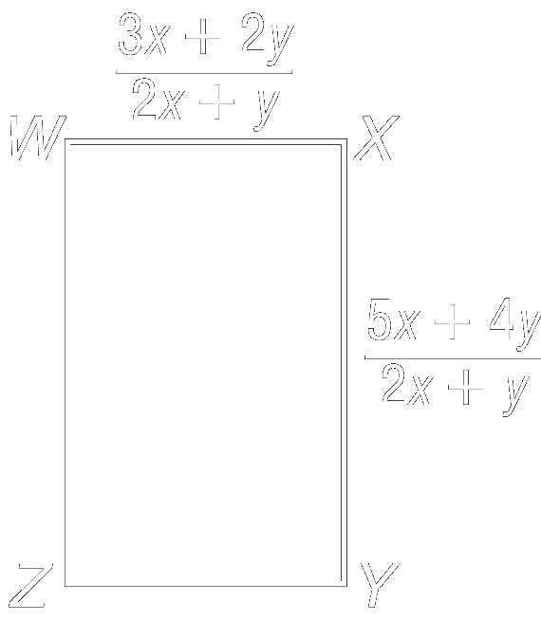
- Simplify
- Geometry: Find an expression for the perimeter of rectangle WXYZ.
- Simplify
- Simplify

Concept Summary:
Add (or subtract) rational expressions with like denominators by adding (or subtracting) the numerators and writing the sum (or difference) over the denominator

Homework: pg
Section 12.7: Rational Expressions with Unlike Denominators

SOLs: None

Objectives: Students will be able to:
Add rational expressions with unlike denominators
Subtract rational expressions with unlike denominators

Vocabulary:
Least common multiple – a
Least common denominator –

Key Concept:

Examples:

- Find the LCM of 12b⁴c⁵ and 32bc²
- Find the LCM of x² – 3x – 28 and x² – 8x + 7
- Simplify
- Simplify
- Simplify

Concept Summary:
Rewrite rational expressions with unlike denominators using the least common denominator (LCD). Then add or subtract

Homework: pg
Section 12.8: Mixed Expressions and Complex Fractions

SOLs: The student will
A.3 justify steps used in simplifying expressions and solving equations and inequalities. Justifications will include the use of concrete objects; pictorial representations; and the properties of real numbers, equality, and inequality.

Objectives: Students will be able to:
Simplify mixed expressions
Simplify complex fractions

Vocabulary:
Mixed Expression –
Complex Fraction –

Key Concept:

Examples:

- Baking: Suppose Katelyn bought 2 pounds of chocolate chip cookie dough. If the average cookie requires 1½ ounces of dough, how many cookies would she be able to make?
- Simplify
- Simplify 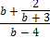

Concept Summary:
Write mixed expressions as rational expressions in the same way as mixed numbers are change to improper fractions.
Simplify complex fractions by writing them as division problems

Homework: pg
Section 12.9: Solving Rational Equations

SOLs: The student will
A.1 solve multistep linear equations and inequalities in one variable, solve literal equations (formulas) for a given variable, and apply these skills to solve practical problems. Graphing calculators will be used to confirm algebraic solutions.

Objectives: Students will be able to:
Solve rational equations
Eliminate extraneous solutions

Vocabulary:
Rational equations –
Work problems –
Rate problems –
Extraneous solutions –

Key Concept:

Examples:
- Solve for x:
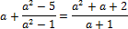
- Solve for x:
- Solve for a:
- TV Installation: On Saturdays, Lee helps her father install satellite TV systems. The jobs normally take Lee’s father about 2½ hours. But when Lee helps, the jobs only take them 1½ hours. I f Lee were installing a satellite system herself, how long would the job take?
- Transportation: The schedule for the Washington, D.C., Metrorail is shown to the right. Suppose two Red Line trains leave their stations at opposite ends of the line at exactly 2:00 P.M. One train travels between the two stations in 48 minutes and the other train takes 54 minutes. At what time do the two trains pass each other?
- Solve for x:

Concept Summary:
Use cross products to solve rational equations with a single fraction on each side of the equal sign
Multiply every term of a more complicated rational equation by the LCD to eliminate fractions

Homework: pg

